Master Gardener Newsletter

YUBA & SUTTER COUNTIES
142A Garden Highway
Yuba City CA 95991
(530)822-7515 FAX 673-5368
http://cesutter.ucdavis.edu
University of California
Cooperative Extension

Coordinator: Jan Kendel Farm Advisor & Program Supervisor: Janine Hasey

So many seeds —so little time. I garden, therefore I am.

September, 2007
AUGUST/SEPTEMBER GARDEN CHORES FOR THE CENTRAL VALLEY,
FOOTHILLS & BAY AREA

(Edie Young is on vacation this month. This article comes to us courtesy of Farmer Fred Hoffman’s website at www.farmerfred.com)

- Train new raspberry and blackberry canes on a trellis or fence. Cut to the ground the old canes which bore this year's crop.
- Brown spots in your lawn? Check your sprinkler coverage of that area. It may be getting substantially less water than other parts of the lawn.
- Extend the flower season by planting more summer and fall bloomers such as petunias, zinnias and marigolds.
- Don't let red tomatoes become overripe on the vine. Pick them when they're fully firm, not squishy.
- To increase flower production on geraniums and fuchsias, pinch them back.
- Keep your roses cool during August. Water deeply and add mulch around the root zone.
- For larger chrysanthemum blooms this fall, disbud them now. Stake and tie the plants to prevent drooping and breaking.
- Marigolds and zinnias can bloom well into the fall. It's not too late to plant more of these seeds.
- To increase the blooms of marigolds, celosia, cosmos, zinnias petunias and impatiens: apply a fertilizer with more phosphorus and potassium than nitrogen, perhaps a formulation such as 5-10-10.
- Fruit and nut trees that would enjoy a bit of fertilizer this month include almonds, apricots, citrus, peaches and nectarines, cherries and walnuts.
- Train new raspberry and blackberry canes on a trellis or fence. Cut to the ground the old canes which bore this year's crop.
- Now is the time for planting seeds of winter vegetables such as broccoli, cauliflower, kale and lettuce. Be sure to keep these new seed beds moist.
- Bermudagrass lawns are growing actively and would benefit from an application of fertilizer. Be sure to water the lawn thoroughly after feeding to prevent grass burn.
- To increase the number of blooms of marigolds, celosia, cosmos, zinnias, petunias and impatiens: remove the dead flower heads so the plant can put its energy into new growth instead of seed production.
- Whenever you spot a fruiting blackberry cane now, mark it with a dab of white paint to remind you to prune it out after you've picked the berries. For new canes on trailing varieties, peg them to the ground to ease your pruning chores.
- Late August is a good time to plant seeds of winter blooming flowers such as sweet peas, snapdragons, Iceland poppies, pansies, violas and primroses. Be sure to keep these new seed beds moist to stave off the drying effects of our warm afternoon breezes.
- If your azaleas and rhododendrons have set their flower buds for next spring's bloom, switch your fertilizer to a 0-10-10 to boost the flower size next year.
- Fallen fruit and vegetables may be harboring next year's pest problems. Clean up and discard these unwanted homes.
- Now's the time to divide crowded clumps of Shasta daisies.
- Get a head start on your winter flower garden by planting early flowering sweet peas, such as "Winter Elegance" or Early Multiflora.

Garden Math: Handy Formulas for the Backyard

* To determine the area of your yard, multiply the length by the width (both in feet). The answer will be in square feet.
* To determine the diameter of a circle (such as a tree trunk): circumference divided by 3.14. To measure the circumference of a tree trunk, wrap a fabric tape measure (or a piece of string) once around the trunk, about waist high.
* To determine the area of a circle: 3.14 times the radius squared. When measuring the area beneath a tree, the radius can be calculated by extending the ruler from the trunk to the drip line (the furthest extension of the tree branches).
* Approximately one cubic yard of mulch will cover 100 square feet with three inches of mulch. A more exact formula: Area (in square feet) times depth of mulch or compost you want to apply (in inches) divided by 324 will give you the number of cubic yards to purchase.
*27 cubic feet equal one cubic yard.
* Three teaspoons equal one tablespoon. Two tablespoons equal one ounce. 16 tablespoons (eight ounces) equal one cup.
* One acre-foot of water represents the need of two average families, in and around the home for one year. An acre-foot covers 1 acre of land 1 foot deep.
1 acre-foot of water = 43,560 cubic feet = 325,900 gallons
1 cubic foot of water = 7.48 Gallons = 62.4 pounds of Water
1 million gallons per day = 1,120 acre-feet per year

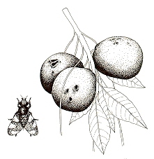 Insect of the Month

Rhagoletis completa
Walnut Husk Fly

http://ipm.ucdavis.edu/PMG/PESTNOTES/pn7430.html

This colorful fly is about the size of a common house fly. It is yellow-spotted with iridescent green eyes and dark bands on the wings that form a “V” shape. Dark, soft blotches on maturing walnut husks mark the presence of the husk fly. Blotches that are dark, dry and hard are indications of a disease known as “walnut blight”. Walnut husk flies have one generation per year, overwinter as pupae in the soil, and emerge as adults to lay eggs from May to late August, peaking from mid-July to mid-August. Homeowners may notice staining of the nuts as the hulls stick to the nuts, but the quality of nutmeats are not affected. Although homeowners do not need to control this pest to have good walnuts, control options include bait and malathion applications. Review Pest Notes 7430 on Husk fly for treatment suggestions.

Weed of the Month

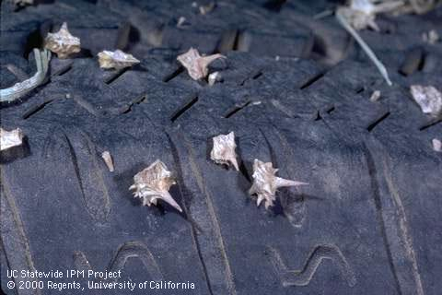

Tribulus terrestris
Puncturevine

http://www.ipm.ucdavis.edu/PMG/PESTNOTES/pn74128.html

Puncturevine is a warm season, mat-forming annual weed with an extensive root system. Leaves are finely divided into 4 to 8 pairs of leaflets, and stems and leaves are covered with fine hairs. The mature plant grows prostrate on open ground but almost erect in dense vegetation. The yellow flowers are borne singly in the leaf axils and open only on sunny mornings, except in shady areas. The fruit consists of clusters of five spiny nutlets or burs, commonly called “goatheads”, which break apart at maturity. Seedlings have thick, elongate, brittle seed leaves, which are green above, grayish underneath and creased along the prominent midvein. The true leaves consist of 8 to 16 leaflets. Apply Roundup when plants are very small, or physically remove them before they go to seed--but be careful--even small plants have seeds that hurt when they stab you!

Plant of the Month

Mazus reptans
Mazus

http://www.mobot.org/gardeninghelp/plantfinder/plant.asp?code=E190

This perennial groundcover grows to 2 inches (!!!) high but one foot wide. A native of the mountains of Himalaya, it creeps and roots at each node but is too slow growing to be invasive. Blooming spring to summer with ¾” wide flowers that are tri-colored purple, white and yellow, this tough little plant takes heavy foot traffic but needs rich soil, water and mulch in the cold winter months.

USDA Zones 3-11 and Sunset Zones 1-9, 14-24

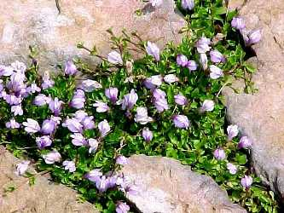
Mazus reptans – Missouri Botanical Garden

NITED STATES DEPARTMENT OF AGRICULTURE, UNIVERSITY OF CALIFORNIA, AND COUNTIES OF SUTTER & YUBA COOPERATING
The University of California prohibits discrimination against or harassment of any person employed by or seeking employment with the University on the basis or race, color, national origin, religion, sex, physical or mental disability, medical condition (cancer-related or genetic characteristics), ancestry, marital status, age, sexual orientation, citizenship, or status as a covered veteran (covered veterans are special disabled veterans, recently separated veterans, Vietnam-era veterans or any other veterans who served on active duty during a war or in a campaign or expedition for which a campaign badge has been authorized).
University Policy is intended to be consistent with the provisions of applicable State and Federal laws. Inquiries regarding the University’s equal employment opportunities policies may be directed to the Affirmative Action Director/Staff Personnel Services Director, University of California, Agriculture and Natural Resour ces, 300 Lakeside Drive, 6th Floor, Oakland, CA 94612-3550, (510) 987-0096.

