
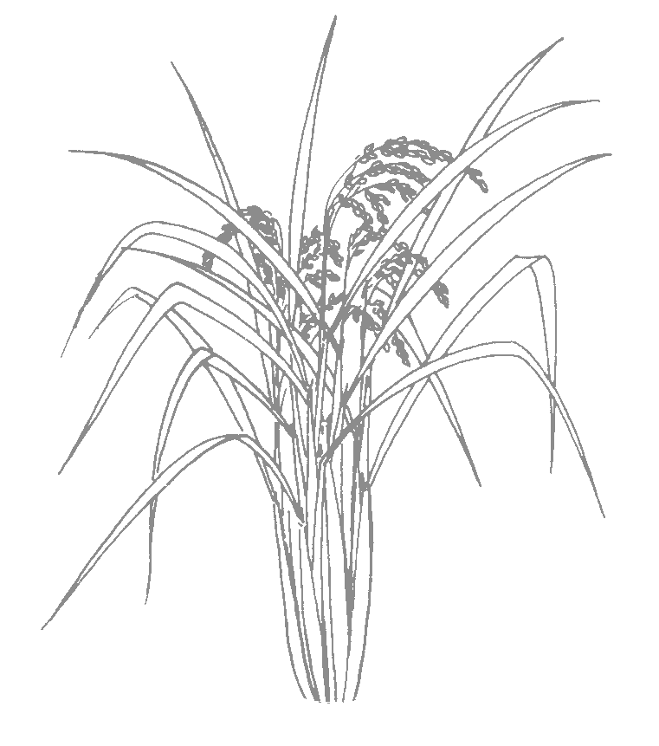
Rice Notes
University of California ~ Cooperative Extension
Sutter/Yuba Counties, 142A Garden Highway, Yuba City, CA 95991, (530) 822-7515, Fax (530) 673-5368
Sacramento County, 4145 Branch Center Road, Sacramento CA 95827, (916) 875-6913, Fax (916) 875-6233
Placer County, 1147 ‘E’ Avenue, Auburn CA 95603, (530) 889-7385, Fax (530) 889-7397

RICE CROPPING SYSTEMS FIELD MEETING

September 7, 2005
9:00 – 11:00 a.m.
Rice Experiment Station

The University of California will host a field meeting at the Rice Experiment Station near Biggs, California. You will be able to observe and/or discuss differences in stand establishment, weed control and fertility management in each of the following five systems:

1. Conventional water seeded
2. Conventional drill seeded
3. Delayed stale seedbed, water seeded (spring tilled and treated with Round-up after the first weed flush and then water seeded)
4. No-till, water seeded (flushed to germinate weeds, Round-up and then water seeded)
5. No-till, drill seeded (flushed to germinate weeds, Round-up and then drill seeded)

Red Rice in California
by Chris Greer, UCCE
Significance and Impact

Red rice poses a serious risk to the California rice industry and has the potential to impact rice yield and quality if this weed is allowed to spread and establish populations throughout rice fields in the state. This weed is prevalent in all of the southern U.S. rice producing states and continues to be a major constraint to production. Red rice is a member of the same species (Oryzae sativa) as cultivated rice grown in California. The name “red rice” refers to the distinguishing red bran that covers the kernels of red rice grain. Red rice is problematic because of the weedy characteristics it exhibits. This weed has a vigorous growth and tillering habit that makes it a better competitor for space and resources than cultivated rice varieties. Competition for these resources leads to reduced rice yields. In addition, red rice has an asynchronous reproductive cycle in which heading may occur over a prolonged period of time producing seeds that shatter easily at maturity. Seeds that fall to the soil surface may germinate when conditions are favorable or remain dormant for several years before germinating. Dormancy of red rice seeds leads to some challenges in developing an effective management strategy for this weed. Chemical control of red rice during a rice cropping season is difficult since this weed is the same species as cultivated rice.

The University of California prohibits discrimination or harassment of any person on the basis of race, color, national origin, religion, sex, gender identity, pregnancy (including childbirth, and medical conditions related to pregnancy or childbirth), physical or mental disability, medical condition (cancer-related or genetic characteristics), ancestry, marital status, age, sexual orientation, citizenship, or status as a covered veteran (covered veterans are special disabled veterans, recently separated veterans, Vietnam era veterans, or any other veterans who served on active duty during a war or in a campaign or expedition for which a campaign badge has been authorized) in any of its programs or activities. University policy is intended to be consistent with the provisions of applicable State and Federal laws. Inquiries regarding the University’s nondiscrimination policies may be directed to the Affirmative Action/Staff Personnel Services Director, University of California, Agriculture and Natural Resources, 300 Lakeside Drive, 6th Floor, Oakland, CA 94612-3550, (510) 987-0096.

Page 2, 2005 August Rice Notes

In addition to competition with cultivated rice plants, red rice is a cause of concern at the mill. The presence of red rice can lower the grade of milled rice. For example, there is a maximum limit of 0.5% red rice and damaged kernels singly or combined) for Grade U.S. No. 1. Removing the red rice seeds at the mill may be done using optical sorters and additional milling but may increase the cost to the miller and result in a reduced price for the producer.

There are a number of management tools we already have in place in California that should be helpful in managing red rice.
- Planting certified seed to minimize the probability of introducing red rice.
- Continuous flooding is suppressive to red rice germination and growth. Avoid prolonged drain periods.
- Crop rotation or field fallowing when possible.

2005 UPDATE - Many of you are aware that red rice was identified in a Glenn County field in 2003. After fallowing in 2004, red rice has once again been identified in this same field. The good news is that efforts to reduce the red rice seedbank in this field appear to be making a significant difference.

There have been approximately 50 red rice plants that have been identified this year and removed from the field prior to panicle emergence. This is a significant reduction in the red rice population that was estimated to be well over 1,000 plants in 2003. The basins where red rice was found in 2003 were left fallow in 2004, flushed twice and sprayed with Round-up following weed emergence after each flush. In 2005, rice was grown in affected checks using stand establishment and herbicide programs that do not require field drainage that encourages red rice germination and growth.

On a cautionary note, red rice was also identified in a field adjacent to the one that was infested in 2003. In conjunction with the grower, Glenn County Agricultural Commissioner, California Rice Experiment Station and California Rice Commission we have been working to develop an effective management strategy for this field. There were three “patches” of red rice that were designated as non-crop areas and treated with a non-selective herbicide. Crews will also be rouging individual red rice plants that occur throughout the field. The key is to kill or remove the red rice plants prior to seed maturation to reduce the population of seed that will serve as a source of red rice in subsequent years. We will continue to monitor these fields and others in the future to evaluate the effectiveness of red rice management programs we have developed.

Red rice has the potential to have a serious economic impact on the California rice industry through reduced yields and quality as well as the costs associated with management of this weed. It is important to note that red rice is not a quarantine issue since it is the same species as cultivated rice. However, the best way to manage this problem is to be proactive in scouting and developing a management program for red rice. If you suspect you have/had red rice in one of your fields, please contact your local UC Cooperative Extension advisor. They will assist you in developing a monitoring and management plan.

North Wind and Grain Quality
by Jim Thompson and Cass Mutters, UCCE

As you know, a North wind period is not good news for head rice yields. Interestingly, it is when the wind stops and the dew returns that the damage occurs. During the first 12 days of a 2004 study, head rice yield and paddy moisture remained consistently high, above 23% (Figure 1). A North wind period

Page 3, 2005 August Rice Notes

from October 8 through 13 caused a drop in average moisture to 11.8% but only an 8 percentage points
reduction in HRY. Rice value (loan value minus drying and receiving costs) actually increased during the North wind period because the paddy was harvested at a low moisture. After the North wind period ended night dew returned and after two days of rewetting the HRY plummeted to 26% and rice value dropped from $5.60/cwt on October 4 to $3.90/cwt on Oct. 16. North wind conditions do not cause much drop in HRY but the dew associated with calm conditions after the wind cause the low moisture paddy to fissure and increase drying cost.

North wind
Figure 1. Harvest date harvest versus moisture content, head rice yield and rice value. Data are cumulative average values for all three basins.

Combining the yield data with the rice value produces grower return in dollars per acre. This increased from $395/ac on the first harvest to $540/ac on the fourth harvest (Figure 2). We did not collect yield data for the last two harvests, but if the yield had remained constant after Oct 4, return increased during the North wind to $557/ac. After the wind stopped the loss in head rice reduced return to $389/ac. It’s a good idea to harvest as much rice as possible during North wind periods. In 2003 we observed that a high HRY was possible after a North wind period if the rice did not dry below 20% to 24% moisture. In 2004 all of the rice dried well below this range and HRY dropped significantly after the wind stopped and dew returned.
Figure 2. Harvest date versus yield and crop value. Yield data were not collected on the last two harvest dates and are assumed to be equal to the yield on October 4.

