Master Gardener Newsletter

YUBA & SUTTER COUNTIES
142A Garden Highway
Yuba City CA 95991
(530)822-7515 FAX 673-5368
http://cesutter.ucdavis.edu
University of California
Cooperative Extension


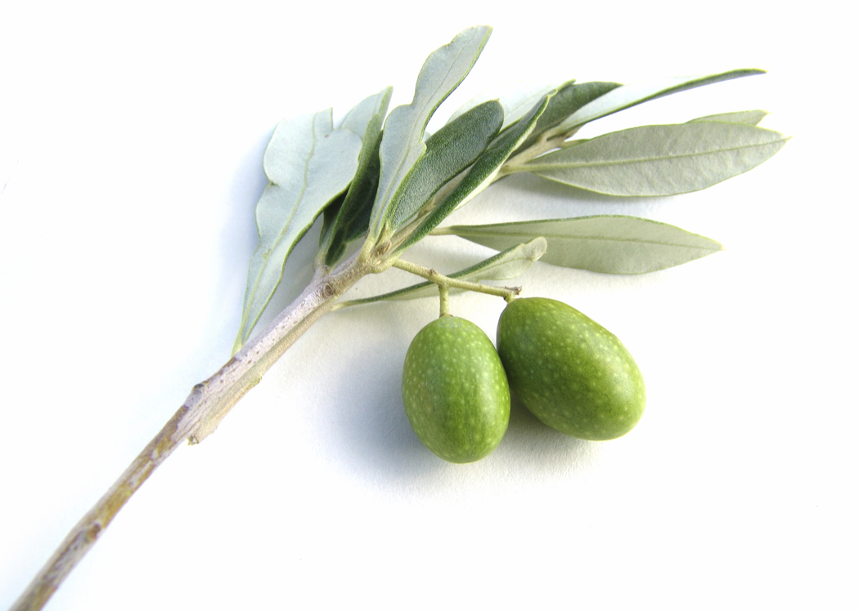
June, 2007

Coordinator: Jan Kendel Farm Advisor & Program Supervisor: Janine Hasey

I’m not really a career person. I’m a gardener, basically. - George Harrison

Timely Tips

There are a lot of things to do in your garden before summer. There is still time to plant those summer vegetables and flowers.

Consider planting sunflowers. Not only can you use sunflowers for decorations, you can use them for people and critter food. Sunflowers come in a variety of sizes and colors. I enjoy the really tall ones because I grow gourds and the tall sunflowers act as trellises for them. I have also grown Burpless cucumbers and green beans using the sunflowers for support. If you don't like sunflowers to eat or don't want to bother husking them, just cut off the heads and lay them out for the birds. The ones we don't eat I feed to the chickens.

Remember, if you are just starting to plant your garden, do not plant the same thing in the same place as last year. It is a good idea to rotate your plantings; for example, tomatoes opposite last year’s plantings, so the soil does not become depleted of nutrients.

I have been having trouble with all kinds of critters eating my strawberries. I have raised beds, and to keep the snails out, I run a copper wire around the perimeter. I was given this tip, and a scientific explanation as to why it works, but I didn't quite catch on - something about electric charges.....Anyway, I tried it and it worked on the snails but then, here came the birds! I had some netting left over from another project and simply laid it over the top of the strawberries. It is held up off the plants by stakes. This tactic seems to be working and at long last, I get to eat whole strawberries.

Good gardening,
Edie Young
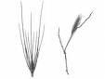

Weed of the Month

Hordeum leporinum
(Poaceae – the Grass Family)

Hare Barley (less common wild barley)
http://www.ipm.ucdavis.edu/PMG/WEEDS/hare_barley.html

I ”discovered” this grass in the ear of my new dog, Kelly, by way of the emergency vet in Chico. This winter annual grows to 10” tall; easily the ear height of a sniffing dog. Auricles, ear-like structures at the bases of the leaf blades, are well-developed, clasping, and paper thin; making it easy to identify this culprit. Hare barley is found mostly in undisturbed areas around the edges of fields, lawns, landscape trees, etc. Awns (the seeds and attachments) can cause serious injury to the eyes, noses and ears of grazing animals or nosey doggies.

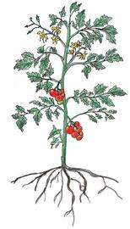

Disease of the Month

Tomato Mosaic Virus (TMV)
(also known as Tobacco Mosaic Virus)

http://www.ipm.ucdavis.edu/PMG/GARDEN/VEGES/DISEASES/tobaccomosvir.html

Leaves have irregular light and dark green color pattern and may be mottled or frilly. Terminal growth may be spindly, with narrow, wrinkled leaves. Resistant plants are available. Do not handle plants unnecessarily; especially after smoking and before washing your hands, because the virus can be transmitted from smoking tobacco. No known cure exists, so plant removal is HIGHLY recommended.

Tree of the Month

Physocarpus opulifolius
(Rosaceae – Rose Family)

Common Ninebark
http://plants.usda.gov/java/profile?symbol=PHOP

Native to eastern and central North America, it grows to 9 feet tall and 10 feet wide, with 3 inch-long leaves that are three-lobed and toothed. Flowers are white to pink, in small to large umbels. Varieties are more attractive than the species. Newer hybrids include ‘Diablo’ (reddish purple), ‘Luteus’ (yellow), ‘Nugget’ (yellow green), and the newest is ‘Coppertime’ (copper colored). For best color, grow in full sun.

USDA Zone 2-10 Sunset Zone A1, A2, 1-10

Insect of the Month

Tipula paludosa
& Holorusia hespera

Crane Fly/Western Giant Crane Fly
(Order: Diptera)

http://www.ipm.ucdavis.edu/PMG/r785301411.html

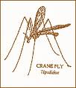

Crane flies can be up to 1 ½” long, generally reddish-brown, with brown wings and broad, white bands on either side of the thorax. Sometimes nicknamed “mosquito hawks” because they look like giant mosquitoes, these delicate insects are commonly seen in spring and summer, attracted to lights at night. “Leatherjackets,” the cylindrical, leathery-skinned larvae, can be semi-aquatic to aquatic and very large (to 60 mm). In the western United States they range from the Pacific Northwest to Southern California. One of the world’s largest flies, it feeds on decaying organic matter in wet soil and can occasionally be a turf pest.

Did you know that….?

Purdue News
November 20, 2003

Stop to smell the flowers-but do it before they’re pollinated!

WEST LAFAYETTE, Ind. – A recent Purdue University study has uncovered the processes responsible for shutting down scent production in certain flowers once they've been pollinated – a finding that may help the horticulture industry enhance floral scent.
Natalia Dudareva, associate professor of horticulture, and her colleagues have recently identified the molecular mechanisms that cause petunias and snapdragons to decrease scent production after they've been visited by pollinators such as bees or moths. The researchers also proved that fertilization, the reproductive process that follows pollination, triggers a decline in scent production. In addition, their research has identified a new role for the plant hormone ethylene.
The study will appear in the December issue of The Plant Cell and is published online in advance of print today (Thursday, 11/20) at The Plant Cell Preview.
"Until now, nothing has been known about the molecular mechanisms that shut down scent production after pollination," Dudareva said. "This study gives us a better understanding of how plants regulate floral scent production and how to improve floral scent in unscented flowers."
Over years of breeding for characteristics such as longevity, color and flower size, many commercially-produced flowers have lost their scent.
"It makes sense. To increase shelf life, a flower needs to save energy, and maybe the trade-off was that these flowers don't expend energy on producing scent anymore," Dudareva said.
To her surprise, she found that while petunias and snapdragons rely on some of the same compounds and processes to produce scent, these flowers regulate their post-pollination scent production in different ways at the molecular level.
In all flowers, a variety of substances known as volatile compounds contribute to floral scent, Dudareva said. A volatile compound called methylbenzoate is one of the most abundant scent compounds in many flowers, including petunias and snapdragons.
Dudareva previously showed that both petunias and snapdragons produce methylbenzoate through a process called methylation. During methylation, an enzyme adds a small molecular unit, called a methyl group, to a compound called benzoic acid, found in the petals. Two different, but related, enzymes called BAMT in snapdragons and BSMT in petunias are responsible for the methylation reaction that produces methylbenzoate and a bouquet's bouquet.
In the current study, Dudareva and her colleagues found that in petunias the plant hormone ethylene, which is produced after pollination, suppresses activity of the gene that triggers the creation of BSMT. Without BSMT, the flower cannot produce the methylbenzoate responsible for its scent.
"In this study we found that genes that regulate scent production are sensitive to ethylene," Dudareva said. "This was entirely unknown and was a big surprise for us."
Ethylene plays a role in many plant development processes, including fruit maturation, leaf drop and various stress responses, but has not previously been shown to play a role in regulating scent.
Snapdragons, Dudareva found, are somewhat sensitive to ethylene, but not to the extent of petunias. While ethylene essentially shuts down scent emission in petunias after pollination, the hormone does not elicit this effect in snapdragons.
Instead, scent emission in snapdragons is regulated by a change in the ratio of two compounds produced in snapdragon flowers, Dudareva said. One of these compounds, called SAM, donates the methyl groups used in the methylbenzoate-producing reaction. The other compound, called SAH, is produced as a result of the methylation reaction. Taken together, the relative amounts of these two compounds are called the "methylation index."
Changes in this index contribute to the decline in scent emission after pollination in snapdragons, Dudareva said.
"It's a feedback loop, and both compounds compete to react with the BAMT enzyme," she said.
Disrupting BAMT activity ultimately decreases production of the scent compound, she said.
While petunias and snapdragons rely on different mechanisms to suppress or decrease scent emission, Dudareva has shown that in both types of flowers fertilization somehow provides a signal to plants, telling them to stop producing scent.
"What we found very interesting is that fertilization, not just pollination, gives a signal to downregulate floral scent," she said. "For two days after pollination, scent does not go down in snapdragons."
When it lands on a flower, pollen produces a structure called a pollen tube. This tube burrows into the flower and makes fertilization possible by giving the pollen access to the flower's ovary.
"Production of scent is an expensive process from an energy point of view, so the question was, why do flowers continue to produce floral scent if they're already pollinated? We found that in snapdragons it takes about 48 hours for the pollen tubes to reach the ovary, and this is what shuts down floral scent," she said.
Petunias also show a delay between pollination and decreased scent production. As is the case with snapdragons, the delay in petunias also matches the length of time it takes for pollen tubes to reach the ovaries, Dudareva said.
This tight coupling between pollination and decreased scent emission makes sense from an evolutionary point of view, she said.
"I think plants want to be sure that they are fertilized before they stop producing scent," Dudareva said. "If they stop producing scent, they won't attract any more pollinators. If the first pollen to reach the flower doesn't reach the ovary, the flower will need to attract more pollinators or it won't produce fruit."
Dudareva suggests that differences in the floral architecture of petunias and snapdragons may account for the different mechanisms these plants use to shut down scent production, but she has not yet investigated this topic experimentally.
"The differences could have to do with floral arrangement on the different types of plants, but it's just a hypothesis," she said.
Collaborating on the study were Florence Negre, Christine Kish and Jennifer Boatright of Purdue University; Beverly Underwood, Kenichi Shibuya and David G. Clark of the University of Florida; and Conrad Wagner of Vanderbilt University.
The National Science Foundation, the Fred Gloeckner Foundation Inc, the American Floral Endowment, the USDA Floriculture and Nursery Research Initiative, and the Florida Agriculture Experimental Station funded this research.
Writer: Jennifer Cutraro, (765) 496-2050
Source: Natalia Dudareva, (765) 494-1325

UNITED STATES DEPARTMENT OF AGRICULTURE, UNIVERSITY OF CALIFORNIA, AND COUNTIES OF SUTTER & YUBA COOPERATING
The University of California prohibits discrimination against or harassment of any person employed by or seeking employment with the University on the basis or race, color, national origin, religion, sex, physical or mental disability, medical condition (cancer-related or genetic characteristics), ancestry, marital status, age, sexual orientation, citizenship, or status as a covered veteran (covered veterans are special disabled veterans, recently separated veterans, Vietnam-era veterans or any other veterans who served on active duty during a war or in a campaign or expedition for which a campaign badge has been authorized).
University Policy is intended to be consistent with the provisions of applicable State and Federal laws. Inquiries regarding the University’s equal employment opportunities policies may be directed to the Affirmative Action Director/Staff Personnel Services Director, University of California, Agriculture and Natural Resources, 300 Lakeside Drive, 6th Floor, Oakland, CA 94612-3550, (510) 987-0096.

